**Part A: Mongo Atlas – Create a New Project and Database**

1. Create a new project under the organization in your Mongo Atlas Account. Click **Next** after enter the project name, and click the **Create Project** button.

Figure A-1: Project Creation

1. Once the program creation completed, setup the deployment from the dashboard by clicking the **Create** button as in Figure 2.

Figure A-2: Create a Deployment

1. Select the M0 server for the free tier and click the **Create** button to proceed. You may choose the region closer to Malaysia.

Figure A-3: Deployment

1. **Create** the default username and password to connect to the database.

Figure A-4: User Authentication

1. Add an entry with the IP address of **0.0.0.0** to allow access to the database from anywhere for the ease of development.

Figure A-5: Network Access List

1. Once the process completed, you should be able to see the database created successfully in the dashboard.

Figure A-6: Completion

**Part B: Github Student Account**

1. Goto <https://education.github.com/benefits?type=student> to create a new Github account using your UTeM Email Address.

Figure B-1: Github Student Account

1. After you successfully verify your education account, activate the Copilot from <https://github.com/features/copilot>.

Figure B-2: Copilot Activation

1. Create a new repository, select a unique repository name for your project.
2. Make the repository **Public**, Add a **README** file, and finally Add .gitignore to **Node**.
3. Click the **Create Repository** button to continue.

Figure B-3: Create Repository

**Part C: Microsoft Azure – Create a Dreamspark Account**

1. Browse to <https://azure.microsoft.com/free/students> to create a student account in Azure using your UTeM Email Address.
2. Fill in the registration form and click the Verify Academic Status complete.

Figure C-1

1. Go to <https://portal.azure.com/#allservices>, click **+** to create a new **Web App**.

Figure C-2: Azure Service List

1. Choose a unique name for the **Web App**. Change the Runtime Stack to **Node 18 LTS**, and the Operating System to **Linux.** Then, select the region closer to Malaysia.
2. Click **Review + Create** button to continue.

Figure C-3: Basic Info

1. Review the summary generated, click the **Create** button the proceed.
2. Wait for the deployment completed, the web app should be listed in the dashboard.

Figure C-4: Summary

**Part D: Microsoft Azure – CI/CD Development**

1. Click the Web App on the dashboard to check on its status and detail.

Figure D-1: Status of the Web App created

1. Go to the **Deployment Center** to setup the CI/CD with Github.

Figure D-2: Deployment Source

1. If you signed in to **Github** in *Step B* previously, the account will be automatically binded. Otherwise, proceed the sign in into **Github**.
2. From the Organization, select the one your create in Github, which should be the same as your account.
3. Select the repository your created in *Step B-5*.
4. Lastly, choose the Branch that you want to link to the repository.
5. Click the Save button on the toolbar to continue.

Figure D-3: Github Deployment Setup

1. After the process completed, you should able to a new commit was added to your repository in the Github.

Figure D-4: Repository Commits

**Part E: Express Framework**

1. Clone the repository into your computer. Then open the folder using VSCode.

1. Open the terminal and enter the npm init, accept all the default value and complete the process.
2. Install the Express Framework with npm install express --save.
3. Create a file index.js in the project folder, and paste the following code:

const express = require('express')

const app = express()

const port = process.env.PORT || 3000;

app.use(express.json())

app.get('/', (req, res) => {

res.send('Hello World!')

})

app.listen(port, () => {

console.log(`Example app listening on port ${port}`)

})

1. Open the package.json file, edit the scripts to as follow:

"scripts": {

"start": "node index.js"

},

1. Save all the files and push a commit to the repository.

1. Go to the Github repository, check on the **Actions** tab to view the CI/CD process for the newly commit change.

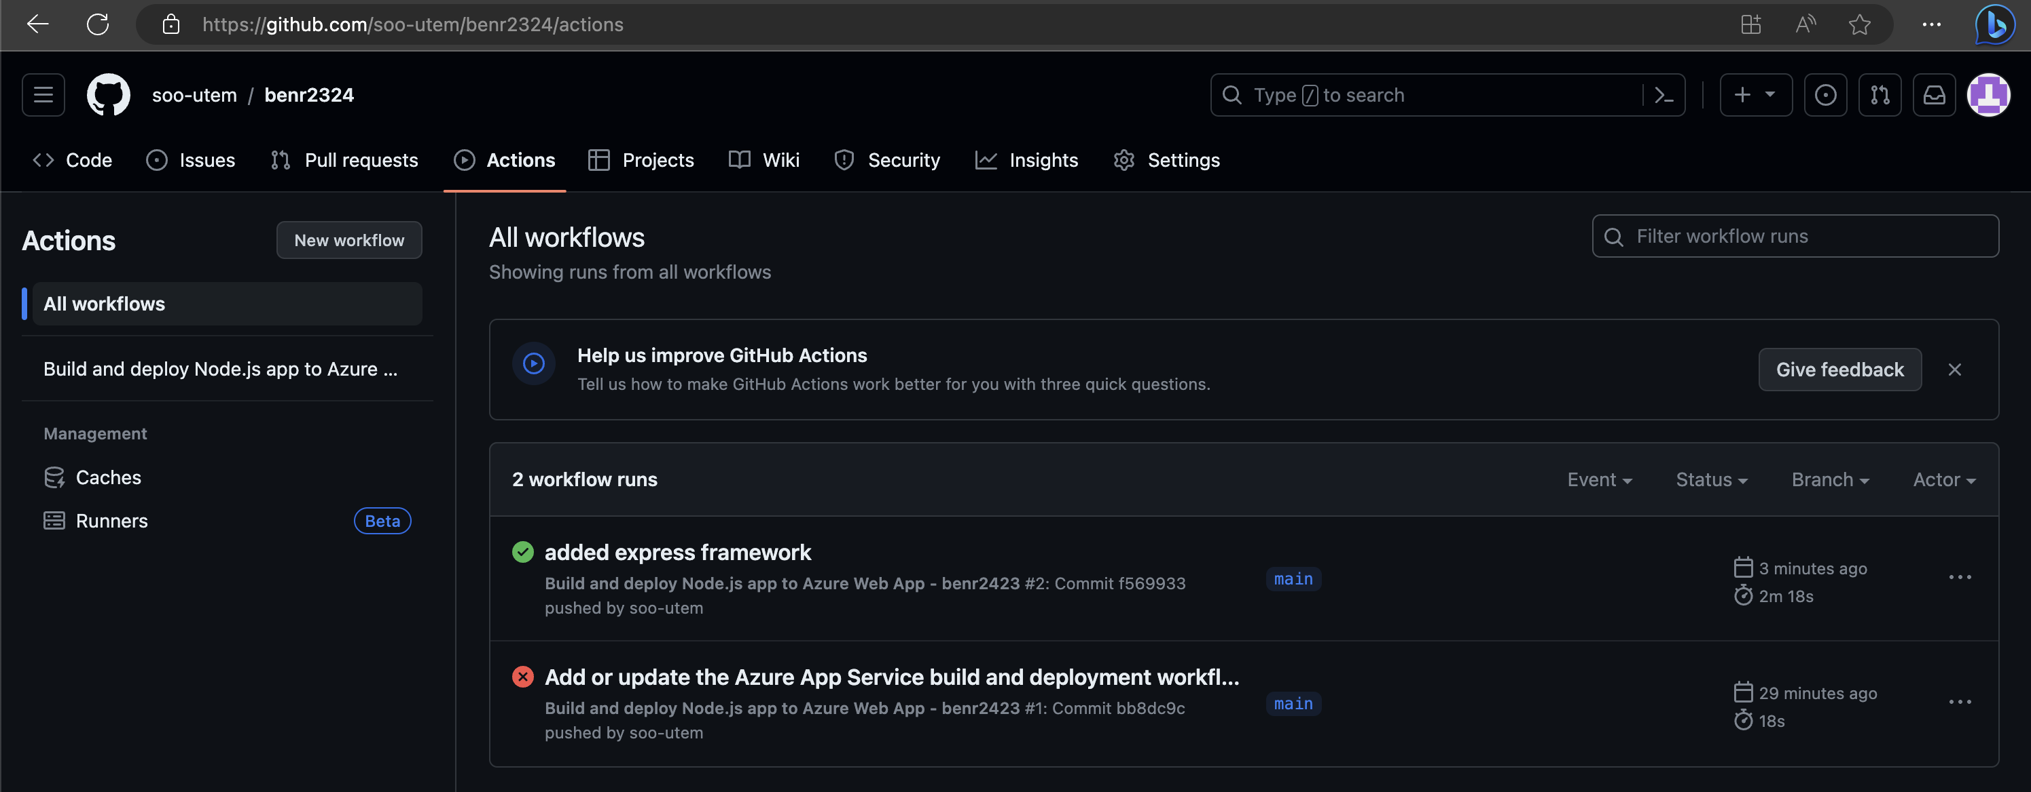

1. Open the Web App address from a browser to verify the result.

